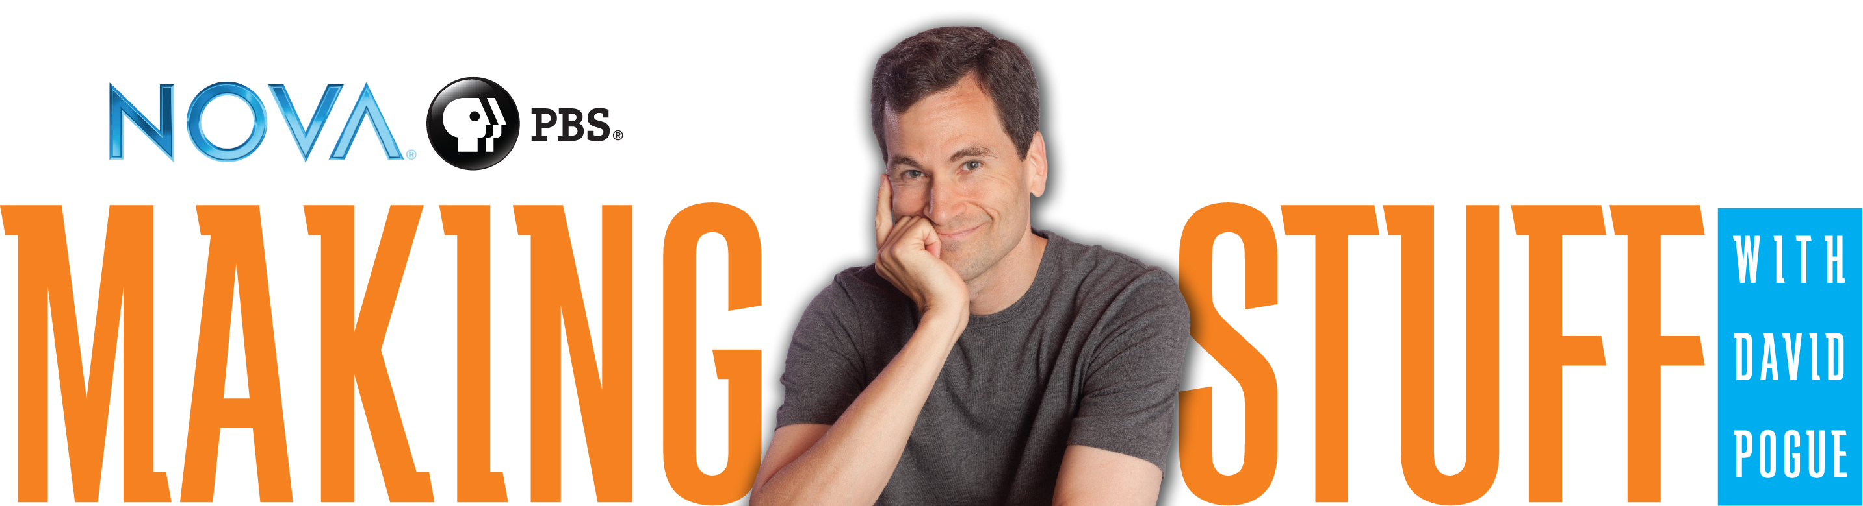

Presentation Talking Points
Talking to Scientists About Communicating Materials Science

Slide 1: Communicating Materials Science with Making Stuff
- Welcome participants to the workshop or presentation.
- Introduce yourself and share why and how you are involved with Making Stuff.
- Brief the participants on logistics: presentation length, coffee breaks, restroom location, fire exits, etc.

Slide 2: What Is Making Stuff?
Making Stuff is more than a broadcast show. Give audience an overview of all the components of Making Stuff: the broadcast series, the national outreach campaign, and related resources.

Slide 3: Making Stuff Video Clip (optional)
If you have audio and video capability, consider including promotional video clip from Making Stuff or delete this slide.
Download video clip at pbs.org/nova/education/makingstuff

Slide 4: Why Stuff?
When considering why to make a series on materials science, we realized how fundamental different materials have been in the course of human history and culture.

Slide 5: Television Series
Details on the series and broadcast schedule.

Slide 6: Making Stuff Episodes
Each episode of the series focuses on a current, overarching aspect of materials science research.

Slide 7: Outreach Campaign Goals
The Making Stuff outreach campaign has goals that are both internal, for the benefit of the materials science community, and external, for the general public.

Slide 8: The Big Picture
When considering preparation for giving a presentation on scientific content, the key areas to address are: audience, message, delivery, and resources.

Slide 9: Components of a Presentation
In this presentation, we will be taking a closer look at each of these four areas.

Slide 10: Audience

Slide 11: Know Your Audience
As you prepare your presentation, first identify your audience. Questions to answer include: Will it be children or adults or a mix? What is their level of scientific knowledge? What might they know about the topic already? Are there any common misconceptions of the science that they may hold?

Slide 12: Middle School
This slide summarizes some science abilities of middle-school students. For this audience, use fewer graphs, charts, and diagrams and instead use a short scenario that allows them to test a hypothesis. Young audiences are particularly excited and engaged by a more hands-on approach to presentations, so consider using an activity from the Making Stuff Activity Guide.

Slide 13: Presenting Materials Science To Young Audiences
Depending on the age and development level of younger audiences, it is good to take different approaches to materials science. With elementary students, stay more concrete and focused on what they can do. With middle school students, explore the behind the scenes of how we make materials and the issues related to their availability. For high school audiences, highlight materials for engineering and design projects and how different materials solve technological challenges.

Slide 14: Message

Slide 15: The Making Stuff Message
There are two key messages that are central to Making Stuff. The graphic on the right shows some of the many fields that are central to materials science.

Slide 16: What’s Your Message?
Think about the parts of your research you want discuss. What is most important for you to communicate to the audience? What will be relevant to your audience? Look for the big picture in a way that is relatable.

Slide 17: Fine-Tune Your Message
Stick to the big ideas in materials science—don’t be sidetracked by the small details. Monitor your audience for restlessness, which often signals that you should move on to the next topic.

Slide 18: Delivery

Slide 19: Ask Yourself…
Do this short poll with your scientist audience to help them with their self-assessment.

Slide 20: You…The Essential Element
When you present, make sure to include your perspective in the story. Why do you care about the topic? How does it relate to your work?

Slide 21: Fundamental Tool
The fundamental tool of presenting is your voice. If we want our audience to be enthusiastic about a topic, we as presenters need to be enthusiastic as well. Be aware that emphasizing certain words in a sentence can result in different interpretations. Your inflection can add an emotional element to your presentation to add impact to your ideas.

Slide 22: The Physical Components
- Face the audience and try to stand in the same spot. Refrain from pacing back and forth in front of the screen, or from constantly stepping forward and back. Do not face the screen and read off of it. If you need to see your slides, set up the computer that is driving the presentation so you can see the slides while facing the audience.

- Make eye contact with the audience members periodically. Eye contact goes a long way in establishing rapport with your audience.

- Speak slowly. Many speakers tend to rush, either from nerves, or the desire to cram more material into their allotted time, or both. Concentrate on speaking slowly, and making every word count.

- Practice giving the presentation out loud at least twice beforehand. This will help you have accurate timing, and to identify problem phrases. If possible, practice with a small audience and solicit feedback on your presentation before delivering it to a larger audience.

Slide 23: The First Five Minutes
Sometimes getting started is the hardest part. Here are a few tips on how to begin a presentation: introduce yourself and explain what you do, talk about your favorite part of your job, connect to them through a short background story.

Slide 24: Tell A Story
Audiences enjoy hearing stories. Stories need a beginning, a middle, and an end. Scientists can fail to communicate effectively to audiences because they assume a prior body of knowledge and a level of interest that does not exist. Start at the beginning. Identify the main researcher(s), their goal(s), the obstacles and challenges that they face in their research, and finally, findings and outcomes.

Slide 25: Be Visual
Visuals can make large amounts of information easily accessible to a broad audience. Some good sources for visual imagery include NASA, NSF and NOAA galleries. Be sure to confirm that you have the rights to use an image or video.

Slide 26: Resources

Slide 27: Outreach Toolkit
The Making Stuff Outreach Toolkit includes resources and guidelines for hosting a variety of science events. Central to the toolkit are 4 demonstrations that are tied to each of the four episodes of Making Stuff. The toolkit can be freely downloaded at the URL at the bottom of the slide.

Slide 28: Activity Guide
The Making Stuff Activity Guide includes four hands-on activities that are tied to each of the four episodes of Making Stuff.

Slide 29: Connecting Resources to Context and Audience
This matrix is a guide to selecting the appropriate resources for your audience.

Slide 30: National Outreach Campaign
This map displays the scope of our national outreach campaign, which includes 20 funded coalition sites and over 200 local outreach partners.

Slide 31: Thank You
Please acknowledge our funders and partners who helped to make these resources available.

Slide 32: {Insert Your Closing Statement Here}

