
PRESS RELEASE FOR IMMEDIATE RELEASE

Contact: Date:
Phone:

[INSERT YOUR ORGANIZATION NAME HERE] Presents MAKING STUFF Event

[INSERT YOUR ORGANIZATION NAME HERE] is partnering with WGBH/NOVA and the Materials Research Society and [INSERT OTHER PARTNER ORGANIZATIONS’ NAMES HERE] to present [INSERT YOUR EVENT NAME/DATE HERE].

Almost everything around you—the clothes you wear, the dishes you eat from, the computer you use, the bike you ride or the car you drive—is made of stuff. Materials science is the study of stuff—what it’s made of, how it works, and what we can do with it. For thousands of years, humans have been manipulating the elements and the world’s raw materials. Now, scientists are generating new materials that function differently and are stronger, smaller, cleaner, and smarter than ever. Expected to revolutionize medicine and technology, these innovations are likely to result in an unprecedented trove of nifty new stuff that is sure to transform the way we live, work, and play. Join us for at for an exploration of stuff, including [INSERT SPECIFIC EVENTS/ACTIVITIES/SPEAKERS HERE]. Doors open at [INSERT TIME HERE]. For further information visit [THE URL OF YOUR EVENT WEB SITE] or contact [INSERT YOUR ORGANIZATION’S CONTACT PERSON NAME/PHONE/E-MAIL HERE].

MAKING STUFF, NOVA’s exciting four-part documentary series, premieres January 19, 2011. MAKING STUFF takes viewers on a thrilling tour of the material world and presents dramatic stories about how the field of materials science has changed history and is shaping the future.Each episode—Stronger, Smaller, Cleaner, and Smarter—gives viewers a behind-the-scenes look at scientific innovations that are happening every day on the frontiers of scientific research and ushering in a new generation of materials. MAKING STUFF is hosted by respected journalist, New York Times technology columnist, and Emmy Award-winning CBS News correspondent David Pogue.

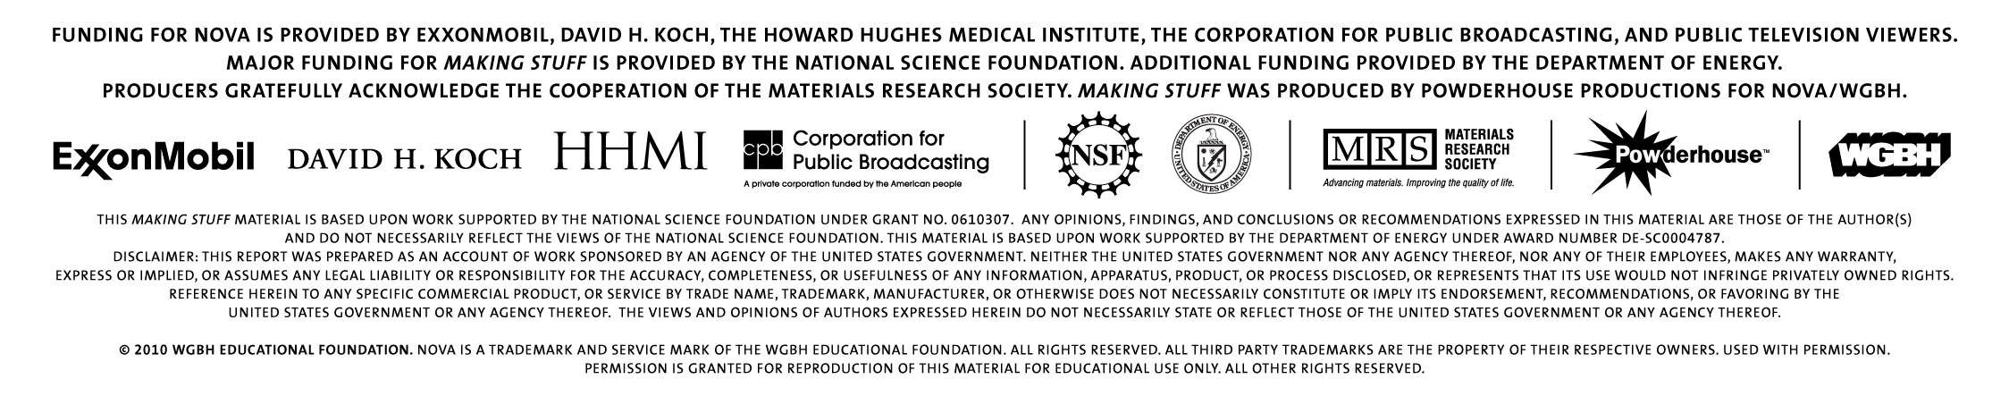

-30-

