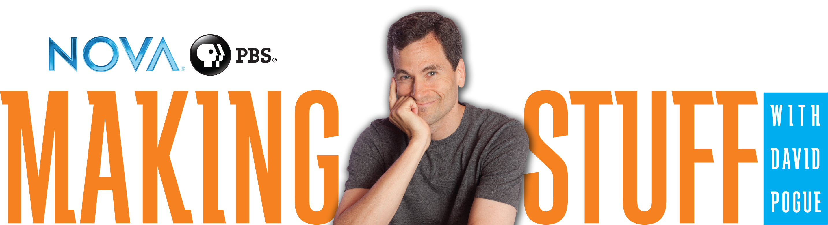

Presentation for Educators
Talking Points

Slide 1: Materials Science Resources for Educators
- Welcome participants to the workshop or presentation.
- Introduce yourself and share why and how you are involved with Making Stuff and your interest and connection to materials science.
- Brief the participants on any logistics: presentation length, coffee breaks, restroom location, fire exits, etc.

Slide 2: Presentation Topics
This presentation will focus on the Making Stuff educational resources available to help you integrate materials science content into your curriculum. Specifically:
- Welcome to Materials Science
- What is Making Stuff?
- The Making Stuff activity guide
- Additional educational resources

Slide 3: Introduce Materials Science
Start with asking the audience to identify their prior knowledge on materials science. Give them time to reflect and share some of their ideas. If the venue and audience size allows, capture some of their ideas on a whiteboard.

Slide 4: Introduce Materials Science
Some audience members may think of cutting edge products and materials such as these. From top left: Nitinol dental braces, microchips and motherboard, shape-memory alloy car parts, Kevlar bullet-proof vests, and bioplastics.

Slide 5: Introduce Materials Science
Other audience members may think of the fields of research that make up materials science, represented by this Wordle graphic showing just a few of the many fields that are central to materials science.

Slide 6: The Making Stuff Message
There are three key messages about materials science that are central to Making Stuff.
- Almost everything around you is made of different materials.
- Materials scientists investigate how materials are made, how they can be changed and improved, and how entirely new materials can be created.
- There are many different kinds of scientists and engineers who are engaged in materials science research.

Slide 7: What Is Making Stuff?
Making Stuff is more than a broadcast show. Give the audience an overview of all the components of Making Stuff: the broadcast series, the national outreach campaign, and related resources.

Slide 8: Making Stuff Video Clip (optional)
If you have audio and video capability, consider showing the promotional video clip from Making Stuff. Delete this slide if you do not use it.
Download the video clip at pbs.org/nova/education/makingstuff

Slide 9: Why Stuff?
Materials have played a fundamental role in the course of human history, evolution, and culture.

Slide 10: Television Series
This slide presents details on the series and broadcast schedule.

Slide 11: Making Stuff Episodes
Each episode of the series focuses on a current, overarching aspect of materials science research.

Slide 12: Host David Pogue
Popular New York Times technology reporter David Pogue is the host of Making Stuff

Slide 13: Making Stuff Resources
Those Making Stuff resources that would be most applicable to educators are listed here. The Making Stuff Outreach Toolkit (shown in the image) includes four demonstrations that are ideal for larger audiences or when you have a shorter time period for engagement. The toolkit can be freely downloaded at the URL at the bottom of the slide. All of the resources, including the toolkit, are available for free download on the Making Stuff Education and Outreach website that is listed at the bottom of the page. It is a live link, so if you click on it you can open the website in your presentation.

Slide 14: Activity Guide
We are going to focus on the Making Stuff activity guide, going in-depth into the four activities that it contains.

Slide 15: Activity Guide contents
Each of the four episodes—Stronger, Smaller, Cleaner, and Smarter—has a corresponding activity.

Slide 16: Standards alignment
Each activity is aligned with certain National Science Education Standards. Notice here that Physical Science and Technology standards have the most direct connection with the materials science content of Making Stuff.

Slide 17: Student activity sheets
Also included in the Making Stuff activity guide are activity sheets for students.

Slide 18: Middle School
This slide summarizes some science abilities of middleschool students. For this audience, use fewer graphs, charts, and diagrams and instead use a short scenario that allows them to test a hypothesis. Young audiences are particularly excited and engaged by a more hands-on approach to presentations, so consider using an activity from the Making Stuff Activity Guide.

Slide 19: Presenting Materials Science To Young Audiences
Depending on the age and development level of younger audiences, it is good to take different approaches to materials science. With elementary students, stay more concrete and focused on what they can do. With middle school students, explore the behind-the-scenes of how we make materials and the issues related to their availability. For high school audiences, highlight materials for engineering and design projects and how different materials solve technological challenges.

Slides 20 - 32: The Activities
The following 12 slides focus on each of the four activities in the guide. If you are limited in time, or only want to cover a few activities, then please remove slides before your presentation. Each activity has three slides that cover the following areas:
- A diagram of the set-up and a basic description of what the students actually do in the activity. This is a good slide to discuss the materials needed for the activity.
- Content connections are ideas for how this activity could connect to specific topics in middle school science. You see a picture of the activity in the guide, as well as kids in action doing the activity. Finally, the teaching tip shares something that we encountered in the design and testing of the activity.
- This final slide is a placeholder for adding the optional video clip from the Making Stuff episode that accompanies each activity. Each clip can be downloaded for free at the URL provided, just click the link to visit the website. If not showing the optional video clip, then delete this slide.

Slide 33: NOVA’s Educational Resources
NOVA is the most utilized video resource in science classroom, and NOVA education supports a vibrant community of educators. Please connect with us on Facebook, through our NOVA Teachers website, or by subscribing to our monthly newsletter, the NOVA SPARK.

Slide 34: WGBH and PBS Resources
WGBH and PBS helps kids grow-up in science. NOVA is a leading member of the STEM pipeline of resources shown here. Point out any that specifically connect to the audience you are speaking to.

Slide 35: Teachers’ Domain
NOVA works closely with the Teachers’ Domain library to provide a collection of STEM media-based resources produced specifically for classroom use.

Slide 36: {Insert Your Closing Statement Here}

Slide 37: Thank You
Please acknowledge NOVA’s funders and partners who helped to make these resources available.

